**Program:**

public class Exception_Multiple_Catch {

public static void main(String[] args){

try{

int den=Integer.parseInt(args[0]);

System.out.println(3/den);

}

catch(ArithmeticException e)

{

System.out.println(e.getMessage());

}

catch(ArrayIndexOutOfBoundsException e){

System.out.println(e.getMessage());

}

}

}

Output:

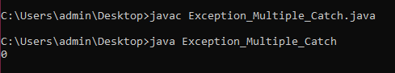

Program:

public class Exception_Multiple_Catch {

public static void main(String[] args)

{

try{

int array[] = new int[10];

array[10]=30/0;

}

catch(ArithmeticException|

ArrayIndexOutOfBoundsException e)

{

System.out.println(e.getMessage());

}

}

}

